ASSIGNMENT-7.1
Name: G.Vignesh
Hall No:2303A52359
Batch:36
Task Description #1 (Syntax Errors – Missing Parentheses in Print Statement)
Task: Provide a Python snippet with a missing parenthesis in a print statement (e.g., print "Hello"). Use AI to detect and fix the syntax error.
# Bug: Missing parentheses in print statement def greet():
print "Hello, AI Debugging Lab!" greet() Requirements:
- Run the given code to observe the error.
- Apply AI suggestions to correct the syntax.
- Use at least 3 assert test cases to confirm the corrected code works.
Expected Output #1:
- Corrected code with proper syntax and AI explanation. Output:

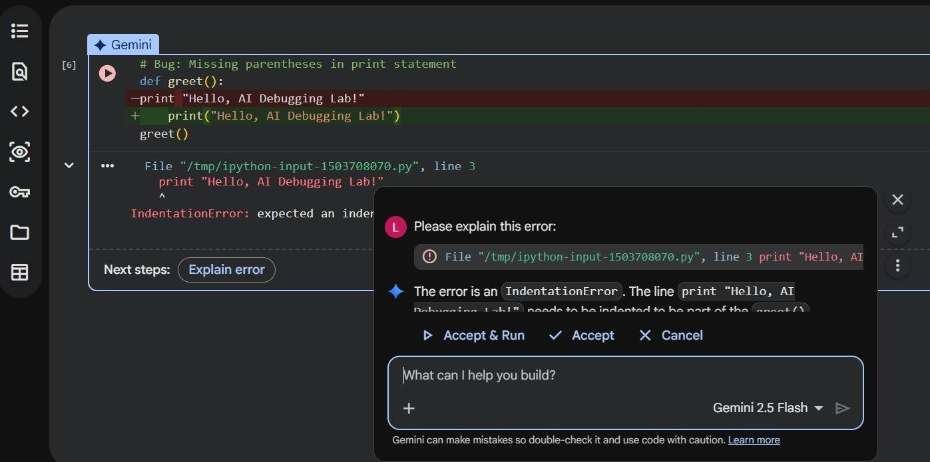
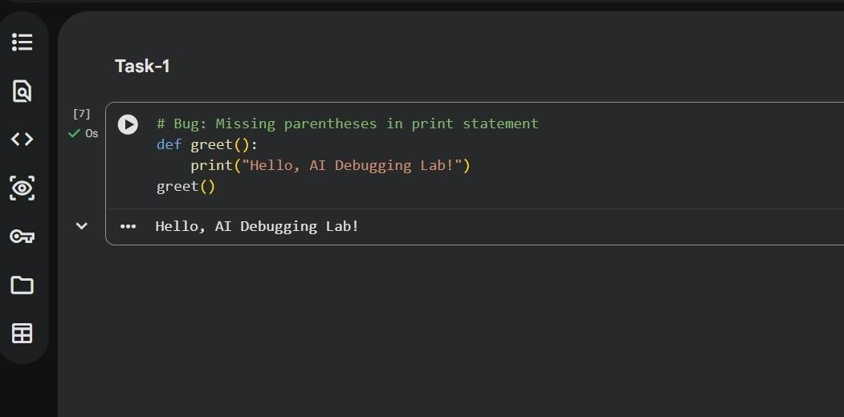
Task Description #2 (Incorrect condition in an If Statement) Task: Supply a function where an if-condition mistakenly uses
= instead of ==. Let AI identify and fix the issue. # Bug: Using assignment (=) instead of comparison (==) def check_number(n): if n = 10: return "Ten" else:
return "Not Ten" Requirements:

- Ask AI to explain why this causes a bug.
- Correct the code and verify with 3 assert test cases. Expected Output #2:
- Corrected code using == with explanation and successful test execution.
Output:
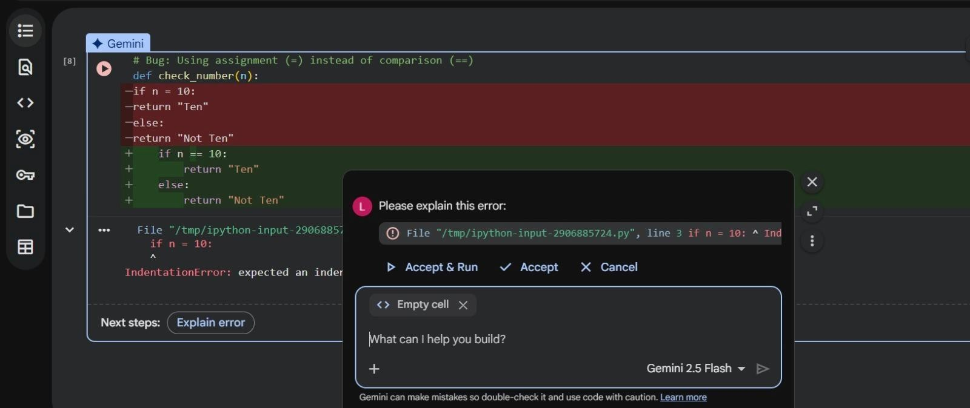
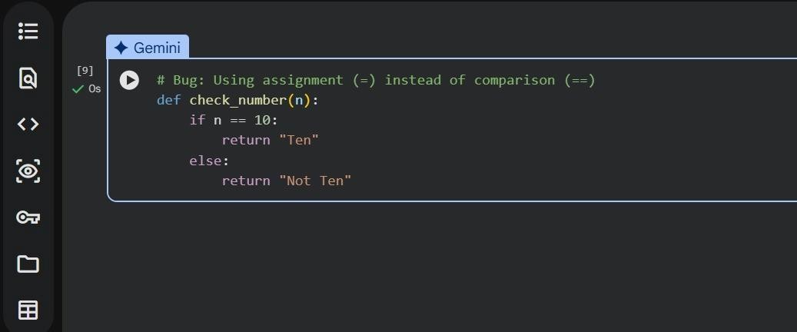
Task Description #3 (Runtime Error – File Not Found)
Task: Provide code that attempts to open a non-existent file and crashes. Use AI to apply safe error handling. # Bug: Program crashes if file is missing def read_file(filename): with open(filename, 'r') as f:

return f.read() print(read_file("nonexistent.txt")) Requirements:
- Implement a try-except block suggested by AI.
- Add a user-friendly error message.
- Test with at least 3 scenarios: file exists, file missing, invalid path. Expected Output #3:
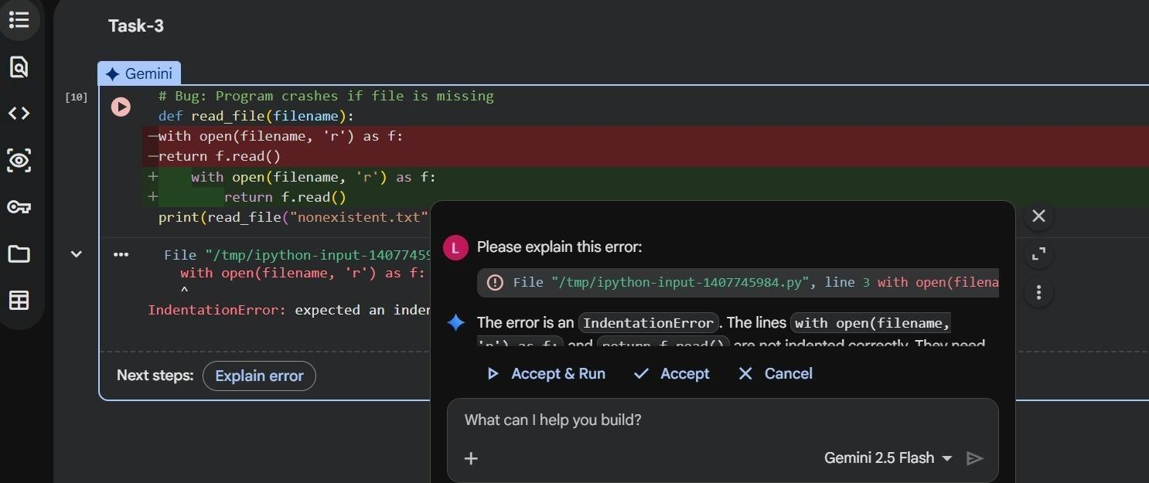
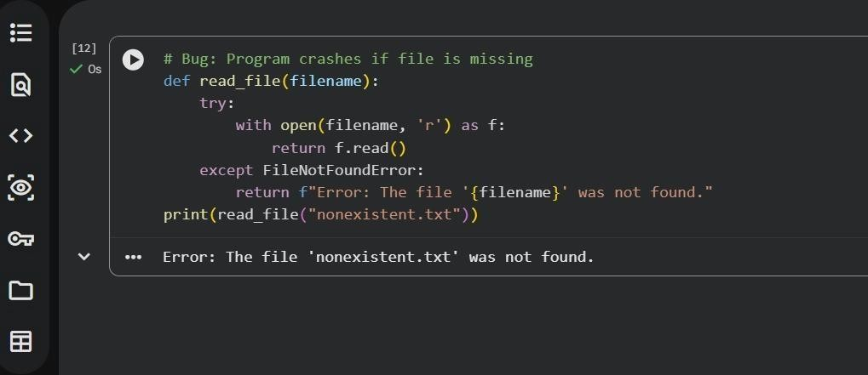
- Safe file handling with exception management. Output:

Task Description #4 (Calling a Non-Existent Method) Task: Give a class where a non-existent method is called (e.g., obj.undefined_method()). Use AI to debug and fix.
# Bug: Calling an undefined method class Car: def start(self): return "Car started" my_car = Car()
print(my_car.drive()) # drive() is not defined Requirements:
- Students must analyze whether to define the missing method or correct the method call.
- Use 3 assert tests to confirm the corrected class works. Expected Output #4:
- Corrected class with clear AI explanation. Output:

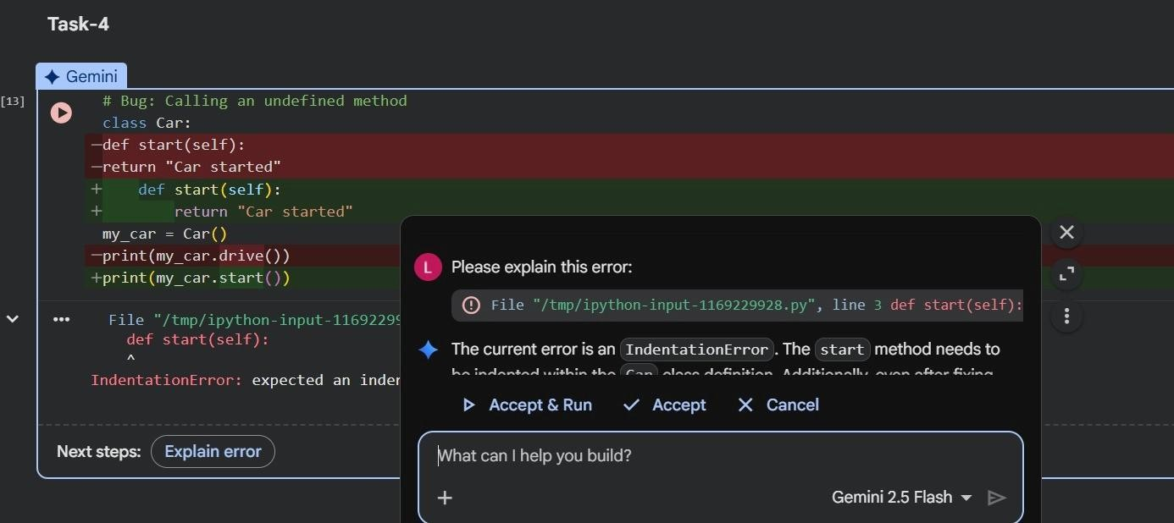

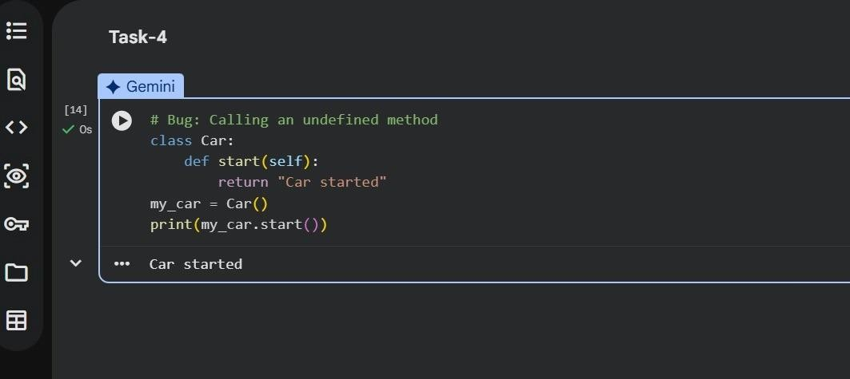
Task Description #5 (TypeError – Mixing Strings and Integers in Addition)
Task: Provide code that adds an integer and string ("5" + 2) causing a TypeError. Use AI to resolve the bug.
# Bug: TypeError due to mixing string and integer def add_five(value): return value + 5 print(add_five("10")) Requirements:
- Ask AI for two solutions: type casting and string concatenation.
- Validate with 3 assert test cases.

Expected Output #5:
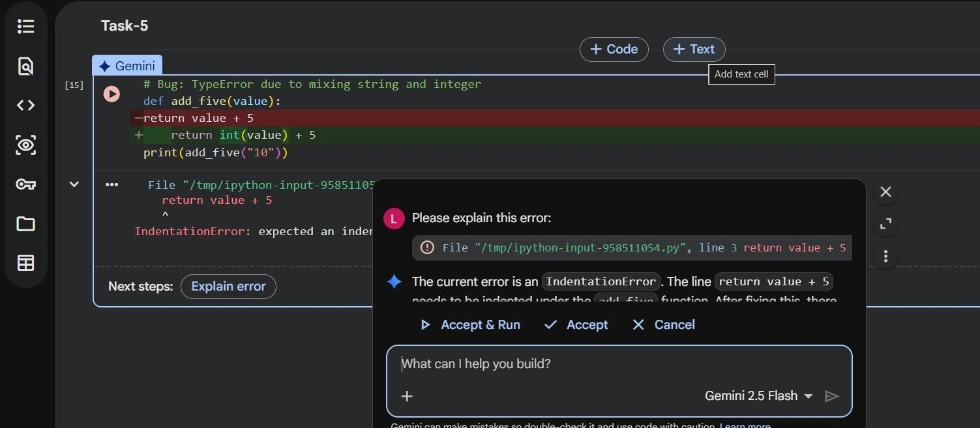
- Corrected code that runs successfully for multiple inputs. Output:

